
SCHOOL NAME: __________________________ EXAMINATION NO: ______________
SOUTH EAST EDUCATION DIVISION
2025 MALAWI SCHOOL CERTIFICATE OF EDUCATION MOCK EXAMINATION

AGRICULTURE

Subject Number: M012/II
Monday, 31st March Time Allowed: 2 hours
10:00 am onwards

PAPER II

PRACTICAL
(40 marks)

Instructions

- This paper contains 4 printed papers.
Question  Number | Tick if answered | Do not write in these columns
1
2
3
4
Please check.
- Before beginning, fill in your full name
at the top of the question paper.
3. Write your answers in the spaces
provided on the question paper.
- This paper contains two sections, A and B.
5. Section A contains two descriptive questions on practical work to be answered
in 1 hour. Marks will be given for accurate and orderly presentation of facts
supported by relevant diagrams.
- In section B, there are two practical questions to be answered in 1 hour.
- Marks for section B will be given for observation, accuracy and interpretation of
results.
© 2025 SEED MOCK Turn over/…

Section A (20 marks)
- Describe the steps which can be followed to preserve mushrooms using Canning method. In your answer include the following materials: water, citric acid, knife, metal cans and a source of heat.
____________________________________________________________________________________________________________________________________________________________________________________________________________________________________________________________________________________________________________________________________________________________________________________________________________________________________________________________________________________________________________________________________________________________________________________________________________________________________________________________________________________________________________________________________________________________________________________________________________________________________________________________________________________________________________________________________________________________________________________________________________________________________________________________________________________________________________________________________________________________________________________________________________________________________________________________________________________________________________________________________________________________________________________________________________________________________________________________________________________________________________________________________________________________________________________________________________________________________________________________________________________________________________________________________________________________________________________________________________________________________________________________________________________________________________________________________________________________________________________________________________________________________________________________________________________________________________________________________________________________________________________________________________________________________________________________________________________________________________________________________________________________________________________________________________________________________________________________________________________________________________________________________________________________________________________________________________________________________________________________________________________________________________________________________________________________________________________________________________________________________________________________________________________________________________________________________________________________________________________________________________________________________________________________________________________________________________________________________________________________________________________________________________________________________________________________________ (10 marks)
Continued/…
- Figure 1 is a diagram showing one of the implement that is used on the farm. Use it to answer questions that follow.
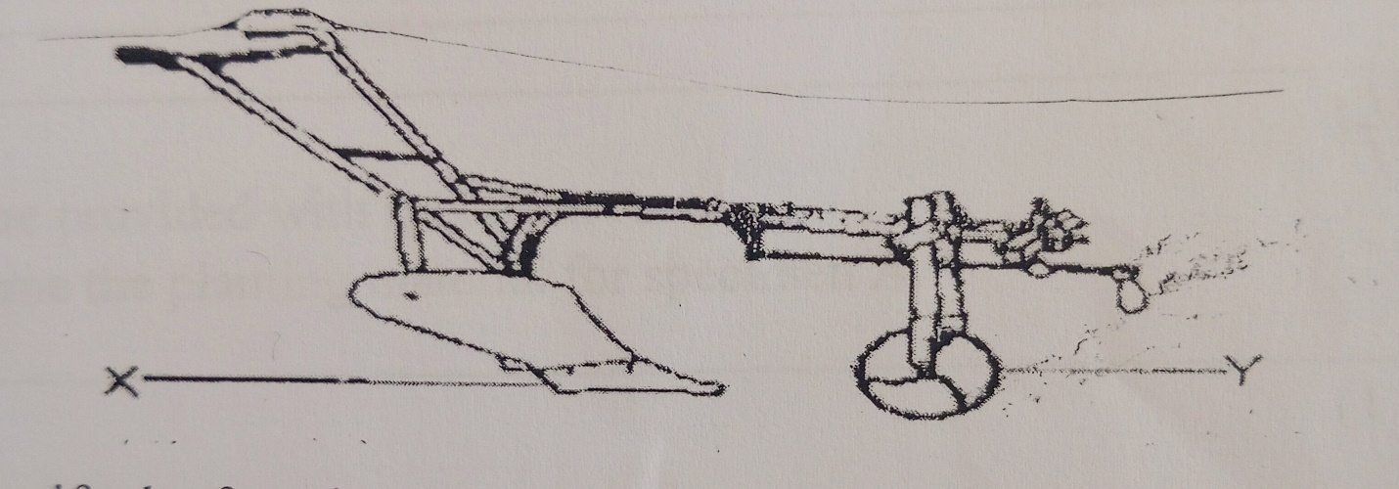
- Identify the farm implement.
__________________________________________________________________ (1 mark)
- Name the parts labelled X and Y
X_________________________________________________________
Y_________________________________________________________ (2 marks)
- Name the source of power for operating the farm implement.
___________________________________________________________ (1 mark)
- Assuming that the farm implement is bought at K120,000 and its salvage value after 2
years is K70,000. Calculate the annual depreciation for each of the 2 years using a straight line method. Show your working.

(6 marks)
3. You are provided with the following specimen.
i. Two maize seeds
ii. One bean seed
iii. Two soil samples labelled X and Y.
Procedure:
- Take one Maize seed and sow it in soil samples X
- Take one bean and one Maize seed and sow it together in soil samples Y.
a. Name the cropping system in X and Y
X: ___________________________________________________________
Y: ___________________________________________________________ (2marks)
b. i. Which cropping system is not suitable for mechanization.
____________________________________________________________ (1mark)
ii. Explain your answer in 3b. (i).
______________________________________________________________ (2marks)
c. State any two disadvantages of crop system in X.
i. ______________________________________________________________
ii.______________________________________________________________ (2marks)
d. which cropping system can reduce the risk of crop failure
_______________________________________________________________ (1mark)
ii. Explain any one reason for the answer in 3d (i).
_______________________________________________________________________________________________________________________________________ (2mark)

- You are provided with specimen L. Use it to answer the questions that follow.
- Draw the specimen and label any two parts.

(3marks)
- Name the material which is used when propagating the above specimen.
_________________________________________________________________ (1mark)
- Suppose a famer would want to conserve the specimen L for future use. Describe the
procedure the farmer has to follow if he wants to preserve it as Hay.
______________________________________________________________________________________________________________________________________________________________________________________________________________________________________________________________________________________________________________________________________________________________________________________________________________________________________________ (6marks)
END OF QUESTION PAPER
NB: This paper contains 4 printed pages.

